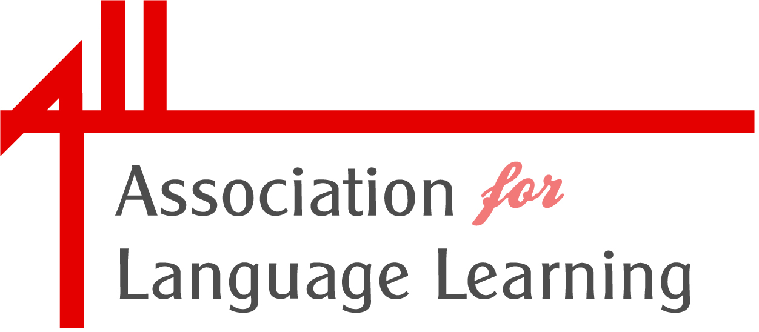

ALL Fellowship Criteria

ALL Individual Members are invited to propose people for fellowship in writing to the Management Board before the Spring meeting, and the Management Board will consult ALL Council about proposals.

The fellowship recognises ALL members:
- who have made a long-standing contribution to language learning in the UK, beyond the call of their professional role
and
- who have supported the work of the Association significantly over time; their contribution might be on the national or local scale.

Nobody can be proposed for fellowship while they are an invited trustee, or are under any contract with the Association; a Fellow will not however be barred from subsequently applying for a governance or elected role, or for a contracted role, with the Association.

Self-nomination for fellowship is not permissible. There is no automatic award to retiring Officers of the Association or staff, and the number of awards will always be small - usually one per year unless in exceptional circumstances.

Benefits of fellowship:
- Membership fee is waived
- Fellows are listed on the ALL website. The Association may celebrate its Fellows’ achievements through occasional inclusions in publications, etc.
- Fellows may include these words in their letterhead /email footer: 'Fellow of the Association for Language Learning'; however there is not an award of post-nominal
- Fellows may wish to take an active role in proposing and leading an activity (a project or seminar, for instance) which furthers the objects of the Association.

Responsibilities of Fellows:
- Being ambassadors for ALL at events which they attend
- Attendance at Language World dinner
- Acting as a sounding board to occasional specific queries from Management Board
- Occasional involvement in judging panels.

Footnote :
The award is lifelong, but may be declined by the recipient at any point, or rescinded in the highly unlikely event of a recipient bringing the Association into disrepute.

